**Experiment 8A**

**Code:**

**<!DOCTYPE html>**

**<html>**

**<head>**

**<script>**

**function bgChange(bg) {**

**document.body.style.background = bg;**

**}**

**</script>**

**</head>**

**<body>**

**<h2>Change background color</h2>**

**<p>Mouse over the squares!</p>**

**<table style="width:300px;height:100px">**

**<tr>**

**<td onmouseover="bgChange(this.style.backgroundColor)"**

**onmouseout="bgChange('transparent')"**

**style="background-color:Khaki">**

**</td>**

**<td onmouseover="bgChange(this.style.backgroundColor)"**

**onmouseout="bgChange('transparent')"**

**style="background-color:PaleGreen">**

**</td>**

**<td onmouseover="bgChange(this.style.backgroundColor)"**

**onmouseout="bgChange('transparent')"**

**style="background-color:Silver">**

**</td>**

**</tr>**

**</table>**

**</body>**

**</html>**

**Output:**

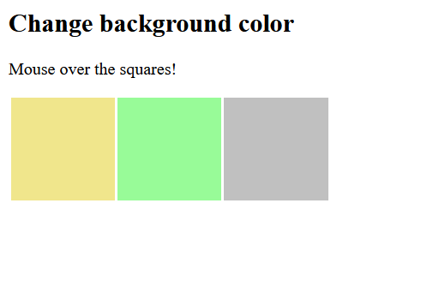

**Experiment 8B**

**Code:**

**<!DOCTYPE html>**

**<html>**

**<body>**

**Enter your name: <input type="text" onfocus="myFunction(this)">**

**<p>When the input field gets focus, a function is triggered which changes the background-color.</p>**

**<script>**

**function myFunction(x) {**

**x.style.background = "yellow";**

**}**

**</script>**

**</body>**

**</html>**

**Output:**

